SIMATS ENGINEERING

ASSESSMENT TOOL 2

COURSE CODE: CSA14 COURSE NAME: Compiler Design

COURSE OUTCOME COVERED

CO4: Examine intermediate code generation techniques to enhance code optimization (BL4)
Assessment Tool Weightage: 20%

QUESTIONS: Total Marks:50

Annexure A

INDUSTRY PROBLEM- SOLVING TASK

Code of Conduct:

I Perarasan V (192521404) (Name / Reg No) certify that this submission is my original work and that I have adhered to the guidelines specified for this assessment.
I understand that any violation of academic integrity rules will result in disciplinary action.

Signature of the student:



Annexure A

INDUSTRY PROBLEM- SOLVING TASK
Q1. E-commerce Order Processing System.
Concepts Covered: Declarations, Assignment Statements, Intermediate Code

Problem Statement
An e-commerce platform processes customer orders. Variables include product price, quantity, tax, and total amount.

Task
- Write declarations for all variables.
- Convert the following high-level code into three-address intermediate code: total = price * quantity
tax_amount = total * tax final_amount = total + tax_amount
- Optimize the intermediate code (if possible).

E-commerce Order Processing System :
Problem: An e-commerce platform computes the order total, tax, and final amount from product price, quantity, and tax rate.
1. Declarations
  - float price;
int quantity;
float tax;
float total;
float tax_amount;
float final_amount;
2. Three-Address Code (unoptimized)
Each binary operation is broken down into a single operator with the result stored in a temporary variable:
  - T1 = price * quantity
total = T1
T2 = total * tax
tax_amount = T2
T3 = total + tax_amount
final_amount = T3
3. Optimized Intermediate Code
Applying copy propagation, each temporary (T1, T2, T3) is used exactly once, immediately after its definition, purely to copy its value into a named variable. The temporaries add no value and can be eliminated by substituting the expression directly:
  - total = price * quantity
tax_amount = total * tax
final_amount = total + tax_amount
No common sub-expressions exist here (each expression uses different operands), so common-subexpression elimination does not apply further. The optimization reduces the instruction count from 6 to 3 and removes 3 unnecessary temporary variables, lowering register/memory pressure.
Verification
The optimized logic above was implemented and run as an equivalent C program to confirm correctness:
C Program — q1.c
  - #include <stdio.h>
int main() {
float price, quantity, tax;
float total, tax_amount, final_amount;
price = 250.0;
quantity = 4;
tax = 0.18;
total = price * quantity;
tax_amount = total * tax;
final_amount = total + tax_amount;
printf("=== E-commerce Order Processing ===\n");
printf("Price : %.2f\n", price);
printf("Quantity : %.0f\n", quantity);
printf("Tax Rate : %.2f\n", tax);
printf("Total : %.2f\n", total);
printf("Tax Amount : %.2f\n", tax_amount);
printf("Final Amount: %.2f\n", final_amount);
return 0;
}
Program Output
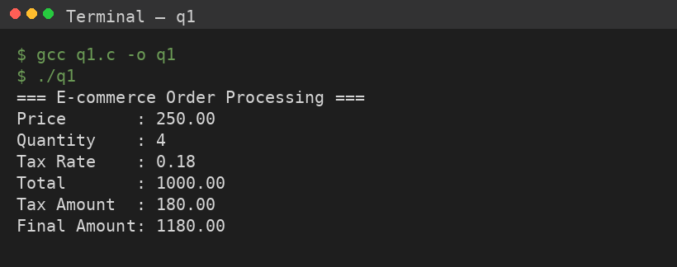

Q2. Online Payment Gateway Concepts Covered: Procedure Calls Problem Statement
A payment system calls functions: validateCard() processPayment() generateReceipt()

Task
- Generate intermediate code for procedure calls.
- Show:
  - Parameter passing
  - Call and return sequence
- Use stack-based representation.

Online Payment Gateway :
Problem: A payment flow calls validateCard(), processPayment(), and generateReceipt() in sequence.
1 & 2. Intermediate Code — Parameter Passing and Call/Return Sequence
  - param cardNo
call validateCard, 1
T1 = returnValue // T1 = valid / invalid
if T1 == false goto L_abort
param amount
param cardNo
call processPayment, 2
T2 = returnValue // T2 = success / failure
if T2 == false goto L_abort
param amount
call generateReceipt, 1
goto L_end
L_abort: print 'Transaction Failed'
L_end:
Each param statement pushes one actual argument onto the parameter list before the matching call n instruction, where n is the argument count; the call itself transfers control to the callee's entry point.
3. Stack-Based Representation
Each call builds an activation record (AR) on the run-time stack. For a call such as processPayment(amount, cardNo):
  - | return value slot |
| return address |
| control link (old FP)|
| param: amount |
| param: cardNo |
| local variables ... | <- FP (frame pointer) for callee
- Caller pushes the return address and the actual parameters (amount, cardNo) onto the stack.
- Caller saves/pushes the old frame pointer (control link) and sets a new FP for the callee's activation record.
- Control jumps to processPayment's entry; the callee accesses its parameters and locals via fixed offsets from FP.
- On return, the callee stores its result in the return-value slot, pops its own AR, restores the caller's FP, and jumps back to the saved return address — this is repeated identically for validateCard() and generateReceipt().
Verification
The three-call sequence (validateCard → processPayment → generateReceipt) was implemented and run as an equivalent C program with explicit CALL/RETURN trace prints:
C Program — q4.c
  - #include <stdio.h>
int validateCard(long cardNo) {
printf("[CALL] validateCard(%ld)\n", cardNo);
int valid = (cardNo % 7 != 0); /* dummy validation rule */
printf("[RETURN] validateCard -> %s\n", valid ? "VALID" : "INVALID");
return valid;
}
int processPayment(float amount, long cardNo) {
printf("[CALL] processPayment(%.2f, %ld)\n", amount, cardNo);
int success = (amount > 0);
printf("[RETURN] processPayment -> %s\n", success ? "SUCCESS" : "FAILURE");
return success;
}
void generateReceipt(float amount) {
printf("[CALL] generateReceipt(%.2f)\n", amount);
printf("[RETURN] Receipt generated for amount %.2f\n", amount);
}
int main() {
long cardNo = 4551234567890123;
float amount = 2599.00;
printf("=== Online Payment Gateway ===\n");
if (!validateCard(cardNo)) {
printf("Transaction Failed: Invalid Card\n");
return 1;
}
if (!processPayment(amount, cardNo)) {
printf("Transaction Failed: Payment Error\n");
return 1;
}
generateReceipt(amount);
printf("Transaction Completed Successfully\n");
return 0;
}
Program Output
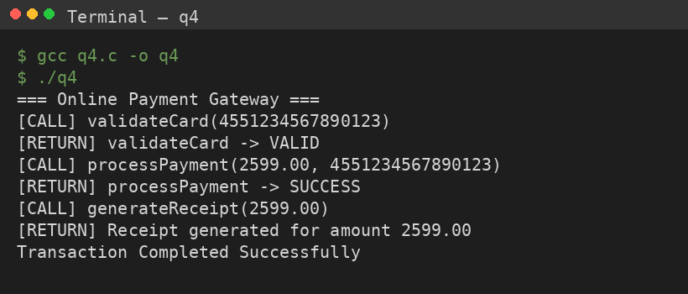

Q3. Smart Home Automation System
Concepts Covered: Boolean Expressions, Assignment, Backpatching

Problem Statement
A smart home system turns ON AC if:
- Temperature > 30 AND Room Occupied

Task
- Write Boolean expressions.
- Convert into intermediate code with short-circuit evaluation.
- Apply backpatching to handle jumps.
- Assign final output to variable AC_status.

Smart Home Automation System
Problem: Turn AC ON if Temperature > 30 AND Room Occupied is true.
1. Boolean Expression
  - AC_status = (Temperature > 30) && (Room Occupied == true)
2. Intermediate Code with Short-Circuit Evaluation
Short-circuit evaluation means RoomOccupied is never even tested unless Temperature > 30 is already true, saving an unnecessary comparison when the temperature condition fails:
  - 100: if Temperature > 30 go to 102
101: go to 105 // short-circuit: skip E2 entirely
102: if Room Occupied == true go to 104
103: go to 105
104: AC status = 'ON'
105: go to 106
105: AC status = 'OFF'
106: (next statement)
3. Backpatching
E1 (Temperature > 30) generates instructions 100–101 with true list={100}, false list={101}. E2 (RoomOccupied) generates 102–103 with true list={102}, false list={103}. Because the connective is &&, backpatch(E1.truelist, label(E2)) links instruction 100 straight into E2's code (short-circuiting), and the combined falselist = merge(E1.falselist, E2.falselist) = {101, 103} is backpatched to the label of the 'AC_status = OFF' instruction once it is emitted.
4. Final Assignment
  - 104: AC_status = 'ON'
107: AC_status = 'OFF'
AC_status now holds 'ON' only when both conditions are true, and 'OFF' if either condition (or both) fail — computed with the minimum possible number of comparisons via short-circuiting.
Verification
The short-circuit && logic was implemented and run as an equivalent C program:
C Program — q5.c
  - #include <stdio.h>
int main() {
float temperature;
int roomOccupied;
const char *AC_status;
temperature = 33.5;
roomOccupied = 1; /* 1 = true, 0 = false */
/* Short-circuit evaluation: RoomOccupied is only checked
if Temperature > 30 is already true */
if (temperature > 30 && roomOccupied)
AC_status = "ON";
else
AC_status = "OFF";
printf("=== Smart Home Automation System ===\n");
printf("Temperature : %.1f C\n", temperature);
printf("Room Occupied : %s\n", roomOccupied ? "true" : "false");
printf("AC_status : %s\n", AC_status);
return 0;
}
Program Output
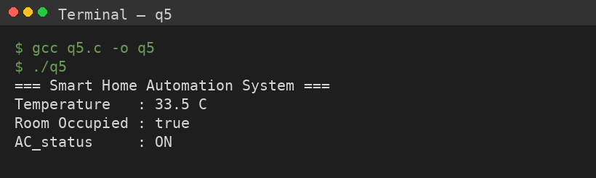

RUBRICS FOR CALCULATION

Numerical Problems
Criteria | Weightag e | Level 4  (Exemplary) | Level 3  (Proficient) | Level 2  (Developing) | Level 1  (Beginning)
Problem  Understandin g | 20% | Clearly interprets problem,  identifies all parameters and requirements accurately | Understands problem with minor gaps | Partial  understandin g; misses key elements | Misinterprets or unable to understand problem
Method Selection | 20% | Selects most appropriate  method/formul a with strong  justification | Selects correct method with minor errors | Inappropriate or partially  correct method | Unable to  select method
Solution Process | 25% | Logical,  systematic steps with correct approach  throughout | Mostly correct steps with  minor mistakes | Disorganized steps;  multiple errors | No clear process
Accuracy of Calculation | 20% | All calculations accurate;  correct final answer | Minor  calculation errors | Frequent errors;  incorrect final answer | No valid calculations
Interpretation of Results | 15% | Clearly interprets results with units and  engineering relevance | Basic  interpretation with minor omissions | Limited or unclear  interpretation | No  interpretation

